Newsletter October 2023

October update - Twinning Project “Further support to the implementation of the National Qualifications Framework” funded by the EU MK IPA 17 SO 01 21
We are pleased to bring you the latest updates from the Twinning Project, showcasing the significant activities that unfolded during the month of October. This month has been particularly dynamic, marked by the successful execution of five missions and the orchestration of a major international conference.

Regional Awareness Raising Events
The first week of October witnessed regional awareness raising events in Skopje, Shtip, and Ohrid. Aligned with Component 4, which focuses on the enhancement of the NQF digital register's interconnection and compatibility at both national and EU levels, these events aimed to empower key national stakeholders. Representatives from various institutions, including the Ministry of Education and Science, NQF Board, VET Center, HE institutions, secondary vocational schools, and the Adult Education Center actively participated.
The primary objective was to discuss the structure and functionality of digital registers with the aim to enhance transparency, comparability, and the recognition of qualifications within the NQF digital register. Participants gained insights into data gathering and management systems. Moreover, these awareness raising events served as a platform for practical knowledge transfer. Activity 4.1.6, focusing on the practical transfer of knowledge and know-how on NQF digital register data structure compatibility interconnection with EU platforms, seamlessly integrated into the layout of the regional events.

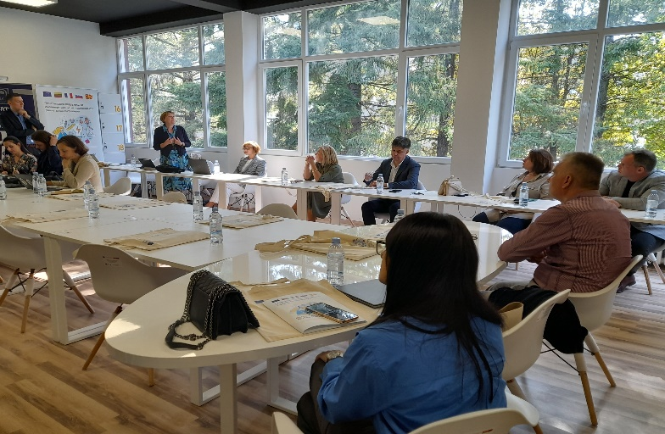
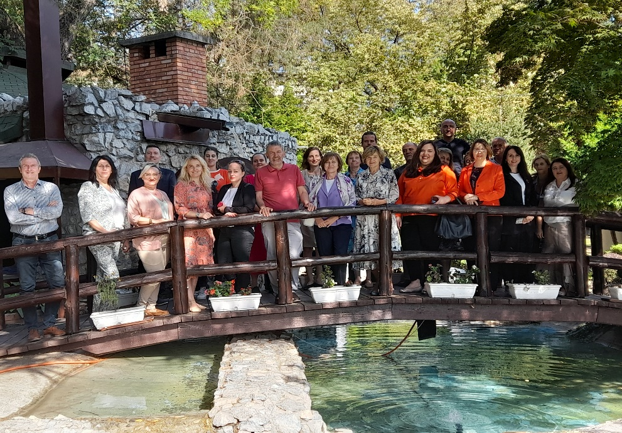

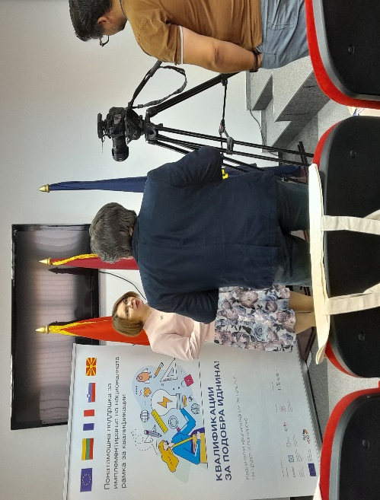

Photos: Regional awareness raising events held in Skopje, Ohrid and Shtip
Continued Progress in Component 2: Advancing National Qualifications Framework
In October, Component 2 achieved significant milestones with the successful execution of the fifth mission within Activity 2.2.3. This activity stands out as one of the most intricate components of the project, addressing the development of qualification standards for the teaching profession across primary and secondary education. Additionally, it extends its scope to cover school support staff and educational service experts, including pedagogues, special educators, rehabilitators, and psychologists. Furthermore, it involves the development of qualification standards for the tourism and hospitality sector, identified as a national priority. Lithuanian and French experts, including Prof. Dr. Rasa Pilkauskaitė-Valickienė, Prof. Dr. Leta Dromantienė, Alain Henriet, and Isabelle Frochot, dedicated their expertise to refining the drafts in their respective fields. Engaging in discussions with key stakeholders, including representatives from the Ministry of Education and Science, the Bureau for Development of Education, academic staff from Higher Education Institutions (HEIs), practitioners in the field of special education and rehabilitation, psychologists in secondary schools, and representatives of the Association of Hotel and Catering Businesses, the experts presented the drafts of the qualification standards. The collaborative discussions led to valuable observations, which were incorporated into the drafts. The final interventions resulted in polished versions of the qualification standards for tourism and hospitality, psychologists, as well as special educators and rehabilitators.
These refined standards are a testament to the collaborative efforts of all stakeholders. They are poised to serve as a solid foundation for the future modernization of study programs, ensuring alignment with the dynamic developments in the relevant sectors.
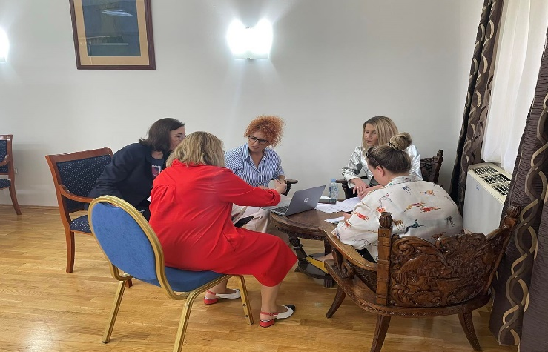
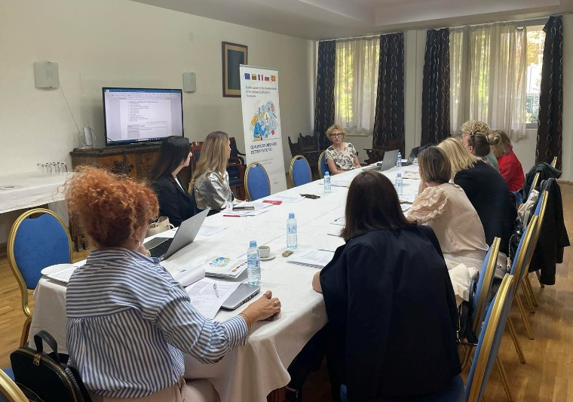

Photos: Meetings to finalize the draft of the qualification standards for tourism and hospitality, special educators and rehabilitators, and psychologists

International Conference: Celebrating a Decade of NQF and Promoting Mobility
The culmination of this month was marked by the organization of an international conference that served multiple purposes. Firstly, it provided a platform for implementing Activity 3.1.4, focusing on conducting public promotion campaigns regarding the possibilities and opportunities offered under the NQF-LLL. Additionally, the conference centered around mobility aspects, spanning education and training mobility as well as employment mobility. Notably, this occasion also presented an excellent opportunity to celebrate the 10th anniversary of the National Qualifications Framework (NQF) in North Macedonia. Last but not least, it served as the perfect venue for distributing various promotional materials developed by the project to disseminate NQF-related information.
Months of meticulous planning preceded the conference, ensuring a seamless experience for the more than 80 participants representing various stakeholders. A promotional banner disseminating basic event information adorned numerous stakeholder websites, accompanied by extensive outreach on social media platforms. Promotional materials, including an informational one-pager and a brochure detailing the NQF's progress over the past decade and future challenges, were distributed. Furthermore, a short video outlining the essence of NQF was developed in three languages: English, Macedonian, and Albanian.
The conference, held on October 19 in Skopje, commenced with welcome speeches from Vice Minister Agim Nuhiu representing the Ministry of Education and Science, and Alexandru Albu representing the EU Delegation. The program featured an overview of the NQF's general development by Natasha Janevska from the Economic Chamber, presentations on the implementation and contribution of NQF in Europe by Zelda Azzara (CEDEFOP) and Maria Rosenstock (ETF), and discussions on NQF's role in mobility and internationalization by Gjorgji Stankovski (National Agency for Erasmus) and Lindita Ferati (Students’ Union).
Breakout sessions focusing on mobility and internationalization of qualifications and the benefits of NQF for employers provided practical insights and generated fruitful discussions.
The conference successfully achieved its main goals of presenting and discussing recent innovations, trends, and concerns, along with practical challenges and solutions in the fields of mobility management and NQF. To inform the general public, a press release was prepared and shared with relevant media outlets, receiving coverage from major news portals in the country.
We express our gratitude to all participants, speakers, and our experts for contributing to the success of this milestone event.
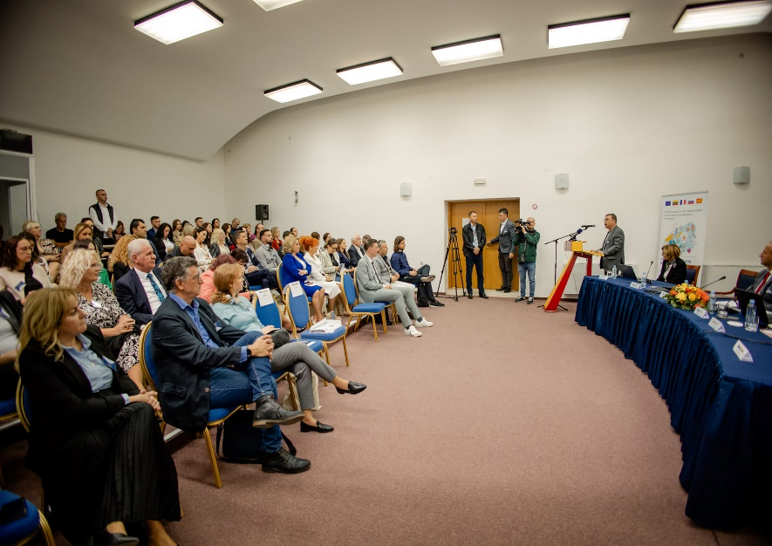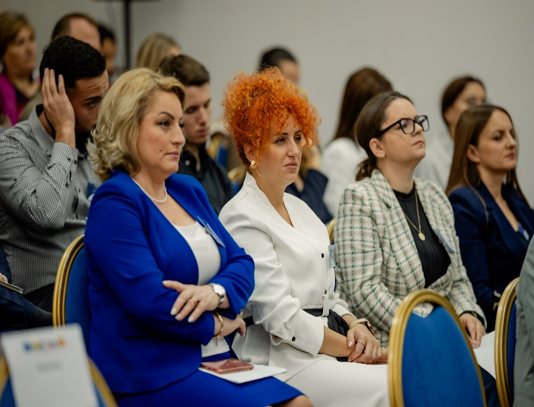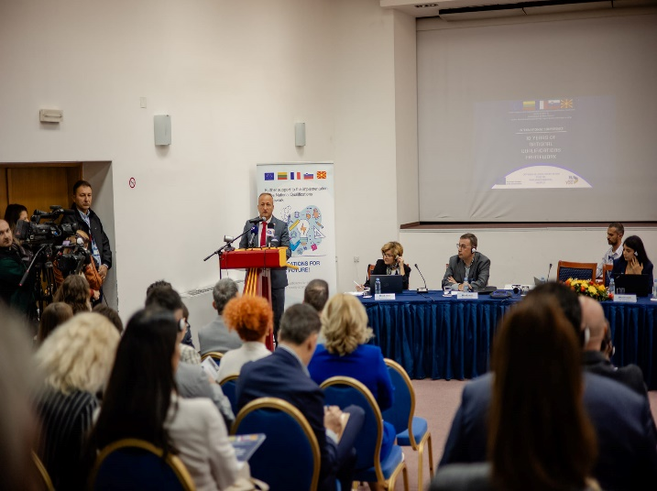
Photos: International conference marking 10th anniversary of the National Qualifications Framework
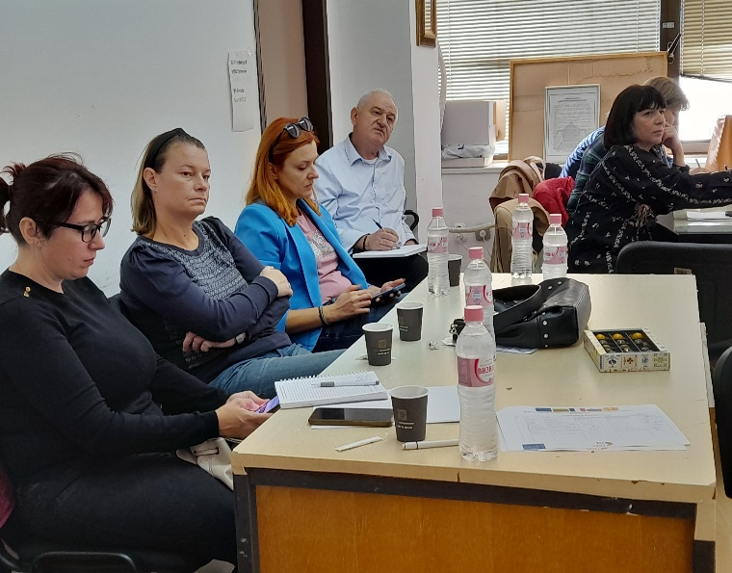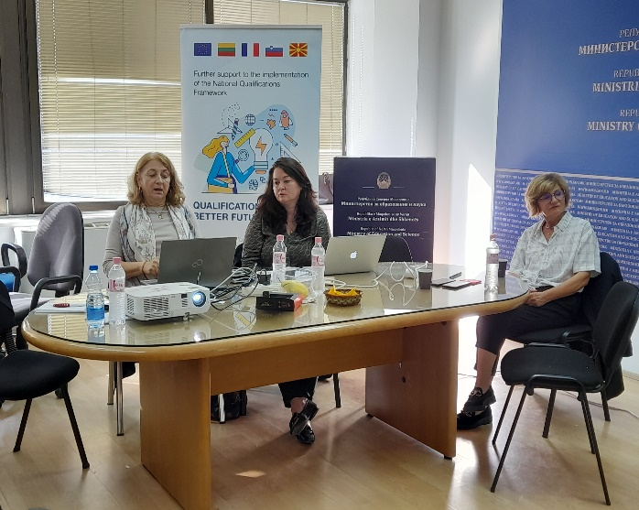
Photos: MS and BC experts developing guidelines and recommendations on the methodology for evaluation of NQF in line with the policy and legal framework for QA in education and training

Crafting a Comprehensive QA Framework
The last activity of the month was dedicated to a collaborative work between the MS and BC experts to developing guidelines and recommendations for evaluation of NQF in line with the policy and legal framework for QA in education and training; development of QA framework in VET referring to the processes and approaches in the development of occupational standards and qualifications, assessment standards; and development of the institutional arrangements, instruments, and procedures of the QA in VET according to the EQAVET. This activity will be finalized in November.

This Newsletter was created and maintained with the financial support of the European Union. Its contents are the sole responsibility of the Twinning project and do not necessarily reflect the views of the European Union.

